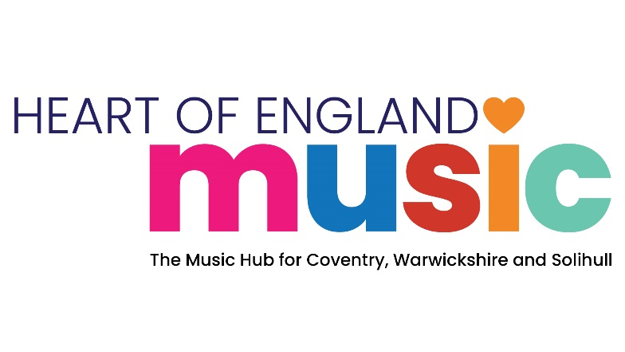

Music Hub Funding Application

**Part 1: Funded Programme Specification**

**Programme Title:** Breaking Barriers - Music Technology Programme

|  |  |
| --- | --- |
| **Funding and Delivery Specification** | |
| **Locality:** | Warwickshire Local Authority Area |
| **Setting:** | Community Based Delivery (outside of Schools) |
| **Music Hub Funding Available:** | Up to £3,000 |
| **Funding Period:** | November 25 to August 26 |
| **Application Closing date:** | 30th September 25 |
| **Completed application return to:** | [richardhart@warwickshire.gov.uk](mailto:richardhart@warwickshire.gov.uk) in M.S Word Format. |
| **Programme Scope:** | |
| We are seeking an experienced and innovative organisation who can work with Heart of England Music to provide a programme of weekly Music Technology opportunities targeting children & young people facing barriers to learning, particularly those with SEMH needs and SEND or who are LAC in central Warwickshire.    Ideally, a termly programme of weekly sessions, ideally of at least 2hrs each delivered to a pre-agreed annual timetable, through the academic year with a showcase opportunity at the end of each term, or at least 2 opportunities within the year. More creative delivery approaches may also be considered.    Particular consideration will be given to applications who have a track record of working with children and young people who face barriers to learning with substantial music technology experience, and available equipped space to deliver their proposed programme.    The successful organisation will be expected to work in collaboration with the Warwickshire Music team. Working alongside other Heart of England Music Hub Partners and Members and working collaboratively with Warwickshire’s Access & Inclusion and Partnerships Strategy Managers.    The ability to provide appropriate cover in response to deliverer absence to ensure ongoing weekly delivery is essential. | |
| **Additional programme information and requirements:** | |
| The funded Delivery Partner will be required to:   * Be a Heart of England Music Hub Member. Membership and funding applications may be submitted together. * Have robust quality assurance safeguarding policy and practice in place to underpin all delivery with children and young people. All delivery staff must have Enhanced DBS checks in place and have received full safeguarding training. * Match the level of Music Hub Funding available for this programme in cash or in-kind terms to enhance the programme scope. * Demonstrate how the proposed programme enhances the organisations current delivery in terms of reach and additionality of breadth of engagement. * Have, and fully fund a remissions policy where charges are made directly to children & young people or their families at point of access.      * Agree to a data sharing agreement with Warwickshire Music and Heart of England Music.      * Acknowledge support from, and display the Heart of England Music, Warwickshire Music and Arts Council Logos on all programme literature, marketing and delivery materials.      * Participate in Music Hub and/or Warwickshire Music events through the year. | |
| **Reporting and data capture requirements:** | |
| Funded Delivery Partner will be required to:   * Provide a short written report on the scope and impact of their delivery in Warwickshire for the Music Hub Board to an agreed termly timeframe.      * Provide student and financial data for their work in Warwickshire in line with Arts Council England Hub reporting requirements in July 26 as required.      * Work closely with Warwickshire Music’s Central Area Leader, Partnerships Manager and Access and Inclusion Managers, meeting at least termly to ensure the success of the partnership and delivery of the programme. | |

**Part 2: Funding Application Form**

**Programme Title: Schools Live Music Programme**

|  |  |
| --- | --- |
| **Organisation Name:** |  |
| **Postal Address:** |  |
| **Website:** |  |
| **Principal Contact Name:** |  |
| **Principal Contact Email:** |  |
| **Principal Contact Telephone:** |  |
| **Is your Organisation a Heart of England Music Member Organisation** |  |
|  |  |
| **Level of Music Hub Funding applied for (up to £5,000 max.)** |  |

|  |
| --- |
| **1. Tell us about your organisation and its track record of delivering opportunities and outcomes that align with the requirements of the programme scope. (500 word max.)** |
|  |
| **2. Tell us how the programme will be planned, managed and delivered to meet the programme scope and additional requirements.  This should include the number /duration of planned delivery sessions, the estimated number of young people engaged, the performance events you plan to provide. (1000 words Max)** |
| . |
| **3. Please provide detail of the match funding (cash and/or in-kind) you will bring to the programme and how it will be used. (200 words max.)** |
|  |
| **4. Tell us how the programme will be developed and sustained beyond the funding period. (500 words max.)** |
|  |
| **5. Tell us how the delivery of the programme will be quality assured (300 words max.)** |
|  |
| **6. Tell us how safeguarding and Health & Safety matters will be managed and reported.** **(500 words max.)** |
|  |
| **7. Tell us how impact and outcome data will be captured and reported to us. (500 words max.)** |
|  |
| **8. If your application is successful, do you agree to enter into a data sharing g agreement with Heart of England Music?** |
|  |
| **9. Is there anything else you would like to tell us to support your application? (500 words max.)** |
|  |

**End**