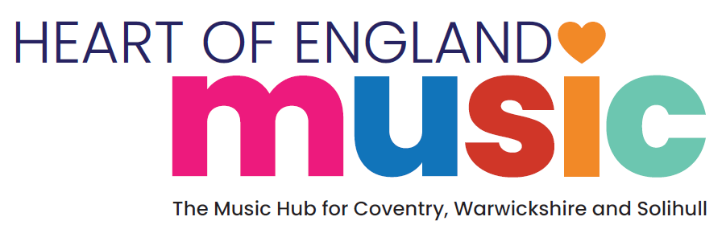
Inclusion Strategy
2025-30
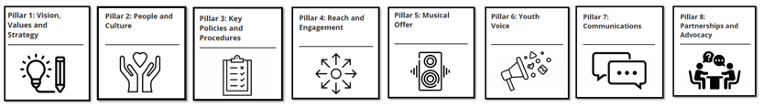
About Heart of England Music
Since the launch in September 2024, Heart of England Music Hub has recruited 31 member organisations to support Hub activity across Coventry, Warwickshire and Solihull. The Hub will work collaboratively with its member organisations to ensure musically inclusive access points and progression routes are mapped across the hub to enable Children and Young people to access musical opportunities and career pathways suitable to their needs and interests. Over the next 5 years we intend to continue to strengthen partnerships with our Hub members, enabling members to collaborate and inform the content of this Inclusion strategy as a live document.

Heart of England Music Hub member organisations

Albany Theatre  Amber Trust  Armónico Consort  Aspire in Arts  Big Sing Soul  CBSO  Charanga  Conductive Music  Coventry Music  Coventry University | Creative Optimistic Visions  Leamington Music  MAC Makes Music  Media Mania  Music of Life  Ode  OHMI  Orchestra of the Swan  Quench Arts  Royal Birmingham Conservatoire | Solihull Music  Spark Youth Music  Talking Birds  The Tin Music and Arts  Sonia Sabri Company  Soundabout  Warwick Arts Centre  Warwickshire Music  Warwick Schools Foundation  Warwickshire and Coventry Youth Brass  Warwickshire Youth Choirs

Our commitment

Heart of England Music Hub is committed to ensuring that access, diversity, and inclusion are the key drivers to our music programming, with the voice of children and young people at the heart of the decisions we make. We will focus relentlessly on equity, diversity and inclusion across the Music Hub – being clear that musical diversity will be the driver for ensuring full access to all.

We want young people across our Hub region, who wish to access our music programmes, to be able to participate, providing enjoyable activities to support their health and wellbeing. We recognise that not all groups of children and young people are represented in our current programming and over time plan to identify resources to develop inclusive, accessible, and relevant activity to meet the needs and aspirations of all children, young people and their families throughout our programming.

Our Inclusion strategy sets out our commitment and objectives to ensure that we will provide an environment and culture that is truly inclusive, where all stakeholders have a sense of belonging, feel valued for who they are, and are supported to be the best they can be. This commitment is in accordance with the Equality Act 2010 which offers legal protection based on a number of characteristics. These protected characteristics are:

- Age
- Sex
- Disability
- Ethnicity
- Gender reassignment
- Religion/Belief
- Sexual Orientation
- Marriage/Civil Partnership
- Pregnancy/Maternity
Any form of behaviour that discriminates against individuals or groups of people based on these protected characteristics will not be tolerated. We recognise that other people experience discrimination or disadvantage because of other characteristics and factors (including political beliefs, trade union status, criminal record, employment status, social class, home address, culture, language, HIV status, or responsibility for dependents) and will work to eliminate discrimination of any kind.

Heart of England Music Hub Inclusion Strategy has been developed using Youth Music’s IDEA framework which ensures the principles of inclusion, diversity, equity and access are considered across all areas of strategy, culture and operations. The framework is broken down into 8 pillars

- Vision, Values and Strategy  - People and Culture  - Key policies and procedures  - Reach and Engagement | - Musical Offer  - Youth Voice  - Communications  - Partnerships and advocacy

Key Pillars and goals on a page

Key pillars | Goals
Vision, Values and Strategy | Embedding EDI in organisational culture and strategy.  Clear expectations across all guidance and communications.
People and Culture | Workforce development through EDI-focused training.  Recruitment, interviews, and inductions align with IDEA principles.  Diverse board and workforce reflecting the communities served.
Policies and Procedures | EDI principles embedded across all policies (e.g. recruitment, induction, quality assurance).  Policies ensure a discrimination-free environment.
Reach and engagement | Use Youth Music Quality Framework to measure impact.  - Increase engagement with underrepresented groups through data-driven strategies.  - Needs analysis to shape inclusion initiatives.
Musical Offer | Expand opportunities and pathways for ages 0-18 (0-25 for SEND).  Target barriers to participation (SEND, SEMH, CLA, Global Majority, Alternative Provision, Youth Justice)  Develop contemporary genre-specific programmes (Drill, Grime, Rap).  Strengthen referral pathways for vulnerable young people.
Youth Voice | Safe spaces for young people to express themselves and influence decision-making.  Career opportunities embedded in Hub delivery (18-25 age group)
Communications | Inclusive, accessible communication across all platforms.  Compliance with accessibility legislation.
Partnerships and advocacy | Work with local, regional, and national partners to expand musical opportunities.  Conduct meaningful consultations with diverse communities.  Advocate for community needs through partnerships.
Inclusion strategy pillars and goals
Pillar | Area of focus | Goals | Success and Impact
Vision, Values and Strategy | Organisational values, culture and strategy | - Organisational values, culture and strategy are established internally and externally by setting clear expectations around EDI in all guidance, communications and digital media.  - All stakeholders have a clear understanding of Hub organisational values, culture and strategy. | There is a widely held perception that the Music Hub embraces and embeds inclusion and diversity within its practice. The Hub’s values, culture and strategy are embedded as a golden strand across all activity.
People and Culture | Hub workforce | - EDI focused organisations are in place who support the Hub workforce to develop and diversify skill sets.  - Inclusion, Diversity, Equity and Access (IDEA) principles are embedded across all recruitment, interview and induction processes.  - Regular CPD opportunities are programmed for Hub members and wider workforce to develop musically inclusive practice.  - Hub workforce has appropriate and sufficient skill, knowledge, and understanding to deliver musically inclusive practice with all Children and Young People.  - Hub board is representative of the community it serves. | The Hub workforce has diversified to more closely reflect and meet the interests, needs and aspirations of Children and Young People represented within the region.
Policies and procedures | Hub policies and procedures | - Inclusion, Diversity, Equity and Access (IDEA) principles are embedded across all policies and procedures across the Hub including, but not limited to, recruitment, induction, quality assurance and remissions. | The Hub has embedded policies and procedures that support the workforce, celebrate diversity, and create environments that are free from discrimination for all stakeholders who engage with the Hub.
Reach and Engagement | Benchmark and measure impact of Hub Inclusion programmes | - Hub to adopt and promote Youth Music Quality Framework as primary tool to benchmark and measure impact of targeted music activity delivered by Hub partners.  - Demographic data demonstrates increasing engagement from underrepresented groups of Children and Young People | The Hub uses data as a driver for inclusion, to identify new audiences, and to benchmark and measure impact of all Hub programmes.  Needs analysis is used as a driver for inclusion, with partners identified to support delivery for particular groups the Hub wishes to engage.
Musical offer | Hub’s musical offer for children and young people. | - Expand musical opportunities and progression routes for Children and Young People across the region aged 0- 18  (0-25 years for children with SEND)  - Expand musical opportunities and progression routes for Children and Young People facings barriers to access and participation including, but not limited to, SEND, SEMH, CLA  - Expand access to programmes for and in collaboration with underrepresented groups of children and young people. Including, but not limited to, groups from Global Majority, newly arrived families/ Alternative Provision/ Youth Justice or developing contemporary musical genres  - Collaborate with Hub partners, members, schools and other agencies to identify and increase referral pathways where vulnerable children in education can regularly access music opportunities | The Hub has developed vibrant, diverse and inclusive programmes of music that meet the needs, interests and aspirations of children and young people across the region.
Youth Voice | Hub wide approach to Youth voice | - Ensure safe spaces where young people feel empowered to speak out, develop themselves, and affect change across all Hub activity.  - Ensure Youth voice is embedded through all Hub delivery, enabling career opportunities for young people 18–25. | The Hub has embedded Young Voice throughout all strands of activity across the region with champions representing groups across the workforce, programmes of activity and governance.
Communications | All Hub communication platforms | - Hub communications reach all stakeholders across region and communities are represented across all platforms. | The Hub demonstrates compliance with accessibility legislation to ensure that people with impaired vision, motor difficulties, learning or cognitive disabilities, and deafness/impaired hearing are able to access the information.
Partnerships and advocacy | Hub member organisations | - Meet the diverse range of needs and interests of CYP across region both now and in future.  - Work collaboratively to gather understanding of local need and find meaningful ways to consult with a wide range of stakeholders and communities.  - Local, regional, and national partnerships enable a diverse range of musical opportunities and pathways for all Children and Young People.  - Partners are advocates for their local communities and support the Hub to develop understanding of local need. | Hub works collaboratively with member organisations to develop comprehensive needs analysis and diversify and expand all aspects of Hub activity across the region.

