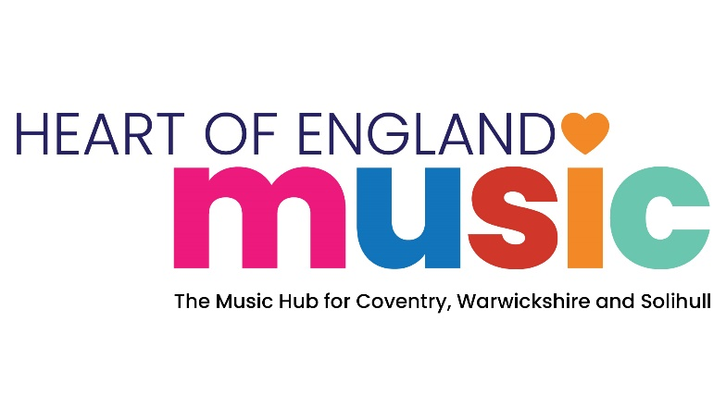

Music Hub Funding Application
Part 1: Funded Programme Specification 2026-2027

Programme Title: School Singing in Warwickshire - From Classroom to Large-Scale Performance
Funding and Delivery Specification

Locality: | Warwickshire Local Authority Area
Setting: | School based delivery with performances beyond the school day
Music Hub Funding Available: | Up to £10,000 (subject to HoEM receipt of Arts Council Music Grant Funding for 2026-2027)
Funding Period: | September 2026 to July 2027
Application Closing date: | 1st July 2026
Programme and application questions may be directed to: | melaniecotton@warwickshire.gov.uk
Completed application return to: | melaniecotton@warwickshire.gov.uk
Programme Scope:
Heart of England Music is seeking to appoint an experienced, innovative, and suitably qualified choral delivery organisation to partner with Warwickshire Music in the design and implementation of a high-quality, bespoke vocal programme for primary schools across Warwickshire. The programme will culminate in a series of locality-based, large-scale performance events delivered across the county.
The successful organisation will be required to deliver a blended model of provision, combining face-to-face delivery with a comprehensive suite of digital teaching and learning resources to sustain the programme for its duration in each school. These self-designed resources must support effective co-delivery with school staff and enable sustained engagement within participating settings.
A key expectation of the contract is the creation of a lasting legacy within Warwickshire primary schools. The appointed provider must demonstrate a clear commitment to building capacity within schools, ensuring that skills, confidence, and infrastructure for vocal learning are embedded beyond the duration of the programme.
Heart of England Music particularly welcomes proposals from organisations that can utilise the available funding to expand and strengthen their existing choral offer within Warwickshire. Applicants should evidence innovation in delivery that enhances inclusivity, accessibility, and artistic quality, while establishing a model that is both scalable and sustainable over time.

Proposals should clearly outline:
- Experience and expertise in delivering high-quality choral or vocal programmes for primary-aged children
- Approaches to blended delivery, including digital resource development
- Strategies for partnership working with schools and co-delivery with staff
- Plans to ensure inclusivity and accessibility for all pupils
- Methods for achieving long-term impact and sustainability within the region especially in rural and hard to reach areas
- Innovative elements that will extend and enrich current choral opportunities
The appointed organisation will work collaboratively with Warwickshire Music to ensure the programme meets strategic objectives and delivers meaningful, high-impact musical experiences for children across Warwickshire.
We would like to know the total number of children & young people the organisation plans to engage in regular choral opportunities through and beyond the funding period.

We are also keen to know how the organisation will work to:

- Make positive connections and build accessible pathway from school-based singing to community based choral opportunities in Warwickshire.

- Build bridges with the existing choral provider landscape within and beyond Warwickshire to enhance singing opportunities across Warwickshire and the wider Music Hub as part of the development of our Music Hub Vocal Strategy.

- Sustain school based singing opportunities beyond this funding period.
Programme performance and success will be measured against the following criteria:
- Engagement of a minimum of 24 primary schools across Warwickshire, with a minimum representation of six schools from each locality; North Warwickshire, Central Warwickshire, East Warwickshire, South Warwickshire as defined by Warwickshire Music.
- Participation of at least 600 pupils in the vocal programme, with clear evidence of inclusive access.
- Creation and delivery of a structured programme of workshops/rehearsals per school, to include at least two in person school delivery visits supported by video resourced vocal support packs aligned to agreed musical and educational outcomes.
- Delivery of four high-quality large-scale live music performance events, one in each of the four defined locality area of the county, each involving at least six schools.
- Demonstrable improvement in pupil musical skills and confidence, evidenced through pre- and post-programme evaluation (e.g. teacher feedback, pupil voice, or skills assessment).
- Positive feedback from participating schools and teachers regarding programme quality, organisation, and impact.
- Effective partnership working with Warwickshire Music, evidenced through regular reporting, planning meetings, and timely delivery milestones.

Additional programme information and requirements:
The Funded Delivery Partner will be required to:

- Match the level of Music Hub Funding made available to them in cash and/or in-kind terms.

- Book and take full responsibility for the management and delivery of 4 locality performance events. Full cost of the events to be covered by a combination of the programme funding and ticket revenue. Ticket pricing should be accessible and include concessionary rates.

- Ensure there is no charge to schools for taking part in the programme but ensure a commitment to their participation in the agreed performance event.

- Establish a data sharing agreement with Heart of England Music

- Support the ongoing development of the Music Hub Vocal Strategy.

- Support Music Hub Conferences and Events through the 2026-2027 Academic Year if required within the scope of the programme funding available.

Reporting and data capture requirements:
Funded Delivery Partners will be required to:

- Provide a short-written report on the scope and impact of their delivery in Warwickshire for the Music Hub Board towards the end of each term; autumn 26, spring and summer 27.

- Provide student and school engagement and financial data for their work in Warwickshire in line with Arts Council England Music Hub reporting requirements in July 2027.

- Work closely with Warwickshire Music’s Partnerships Manager, meeting at least termly, or more often to ensure the success of the partnership and delivery of the programme.

Part 2: Funding Application Form

Programme Title: School Singing in Warwickshire - From Classroom to Large-Scale Performance

Organisation Name:

Postal Address:

Website:
Principal Contact Name:
Principal Contact Email:
Principal Contact Telephone:
Is your Organisation a Heart of England Music Member Organisation? | Yes/No
Level of Music Hub funding applied for (up to £10,000 max).

1. Tell us about your organisation and its track record of delivering opportunities and outcomes that align with the requirements of the programme scope. (500-word max.) | Leave Blank
2. Tell us how the programme will be planned, managed and delivered to meet the programme scope and success criteria. (1000 words Max) | Leave Blank
3. Please provide detail of the level and type of match funding you will bring to the programme and how it will be used. (200 words max.) | Leave Blank
4. Tell us how the programme could be sustained beyond the funding period. (500 words max.) | Leave Blank
5. Tell us how your delivery is quality assured (300 words max.) | Leave Blank
6. Tell us how all safeguarding and Health & Safety matters will be managed to ensure safe and sound programme delivery for all children and adults participants involved. This should include reference to all relevant policy and compliance processes. (500 words max.) | Leave Blank
7. Tell us how impact and outcome data will be captured and reported to us. (500 words max.) | Leave Blank
8. If your application is successful, do you agree to enter into a data sharing agreement with Heart of England Music and provide all necessary data & information to the required timeframes. | Leave Blank
Yes/No

9. Is there anything else you would like to tell us to support your application? (500 words max.) | Leave Blank

Please return completed applications to: melaniecotton@warwickshire.gov.uk in M.S. Word format by 1st July 2026

